**CREDIT SCORING ANANLYSIS PROJECT**

1. **Problem Statement**

Analysis of the following is required by the Omni Channel Manager:

Build a Credit Scoring Model, enabling them to make data-driven lending decisions.

1. **Dataset**



1. **Data analysis**

This data contains 3000 records with 30 columns.

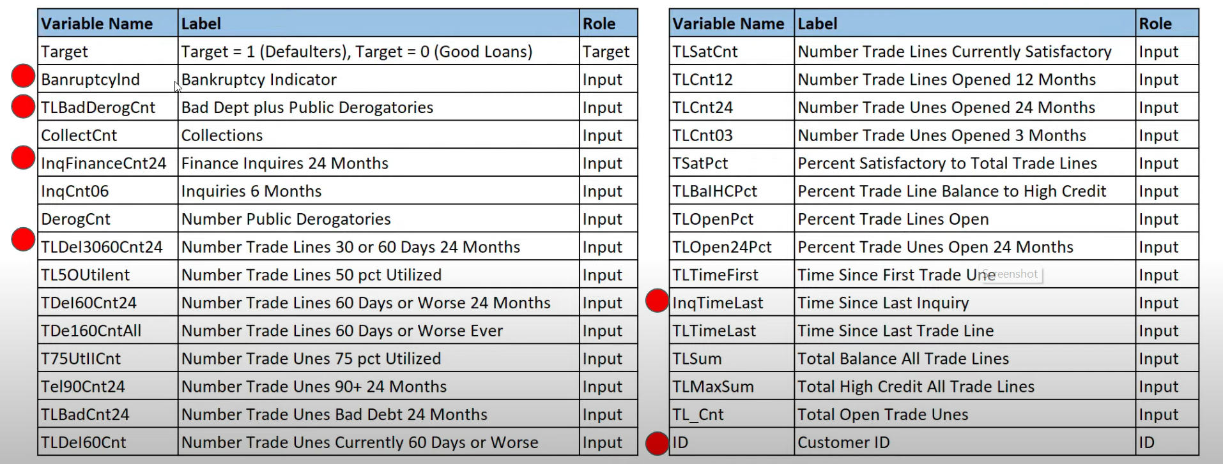

And there are 2 types of loans: good loans (0) and bad loans (1).

1. **Technologies:**

**Tools Used:**

AWS S3 is used for storage.

Alteryx for ETL



.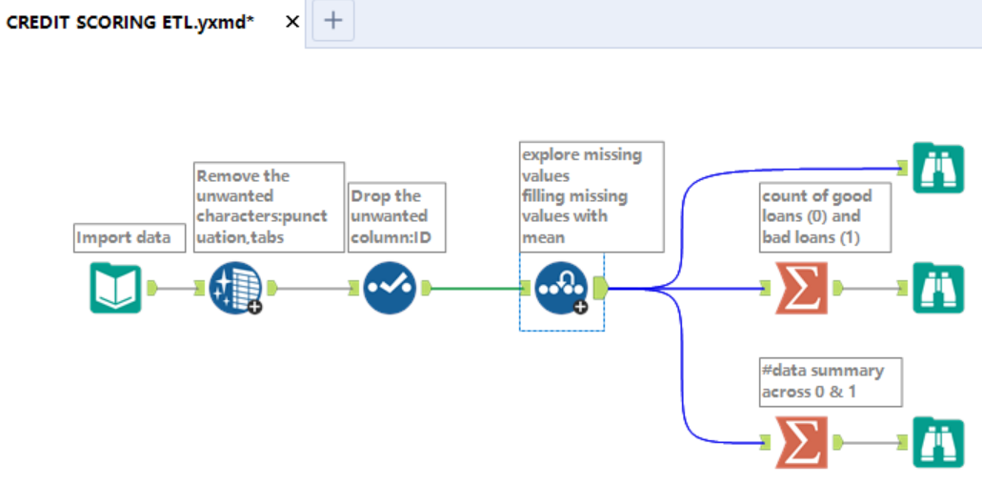

Jupyter Notebook is used as IDE.

Utilized the credit scoring model via logistic regression classifier in Python.



For visualization of the plots, Power BI is used.

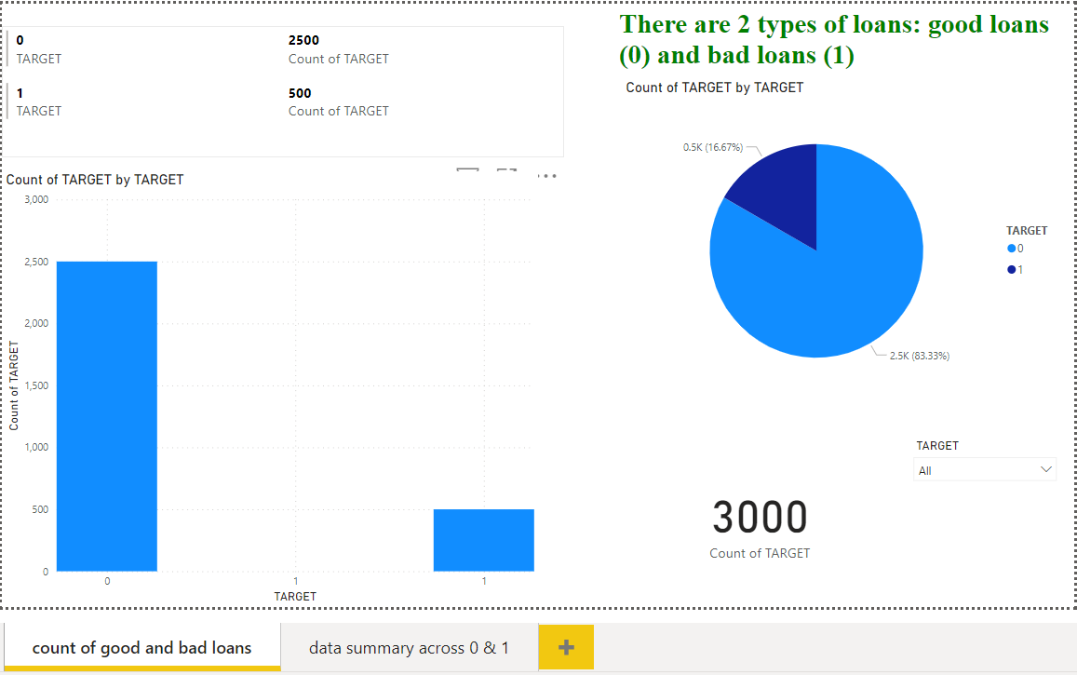

Applied decile methodology to formulate the lending strategy in Excel.



1. **Conclusions:**

